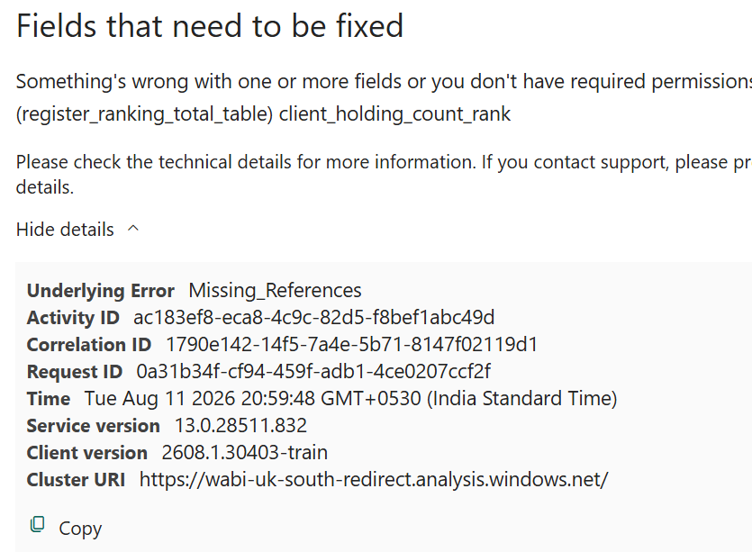
After open and verify the original semantic model see the client holding count rank isin register client summary table and also that is not a measure it is a column only then why this error causes tell me and give idea to get rid of this error.

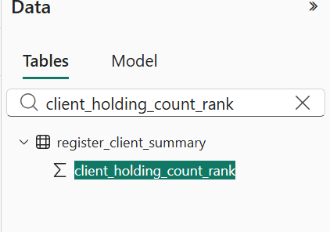

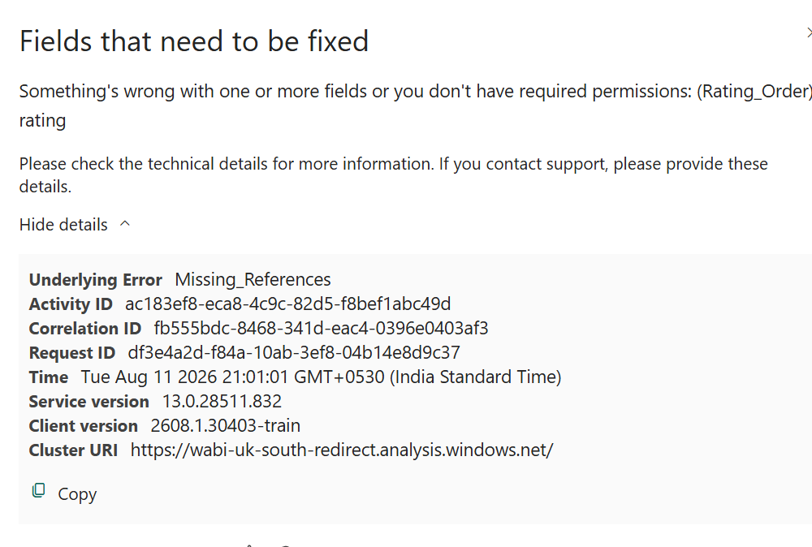
Here also same rating inside client concerns and this is also column
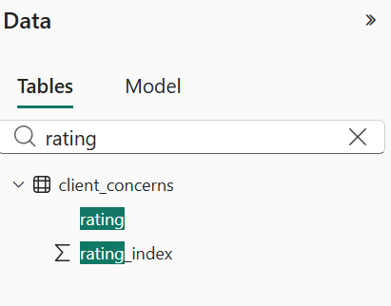

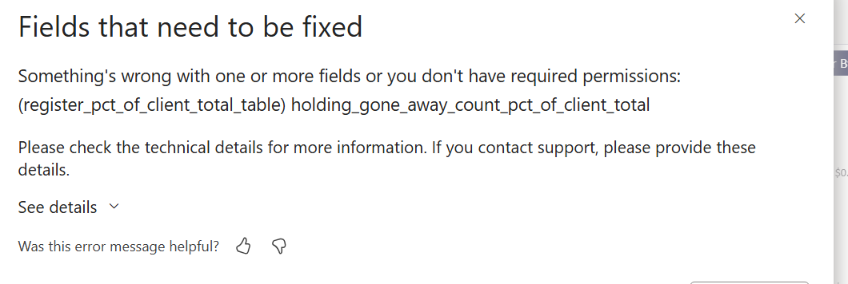

See when I search for this holding gone away count pct of client total inside the semantic model 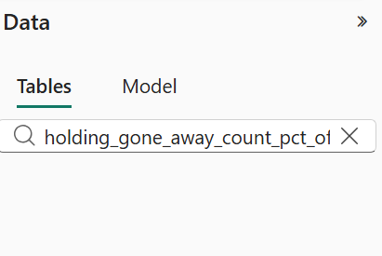
See there is no measure like this inside the semantic model and also there is no table called register pct of client total table
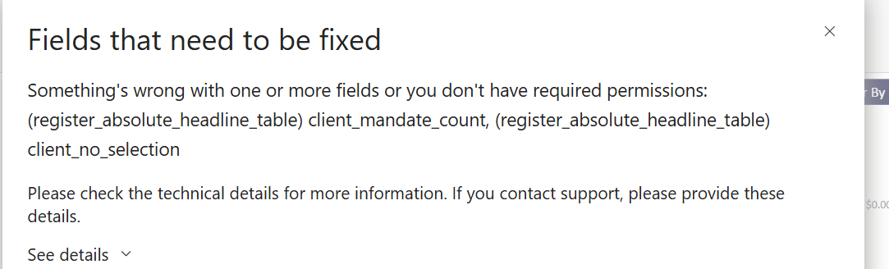
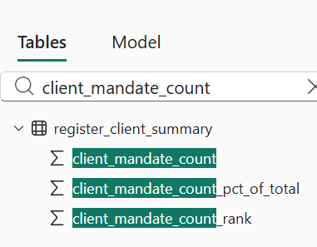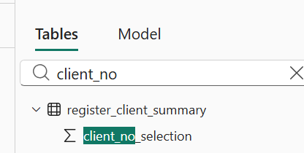
These columns are inside the register_client_summary table theres is no table called register absolute headline table for this what is the solution

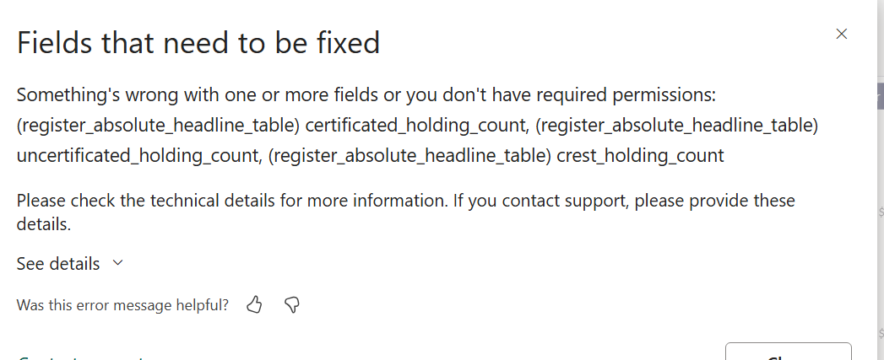
These columns are also inside the register client summary table not there is a table called register absolute headline
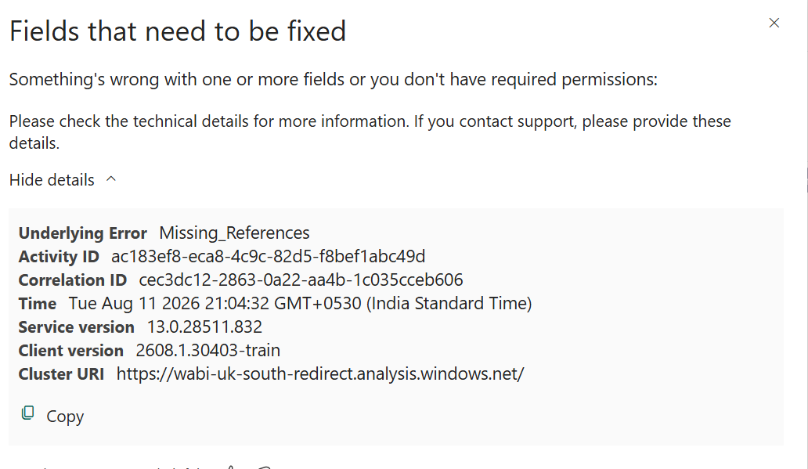

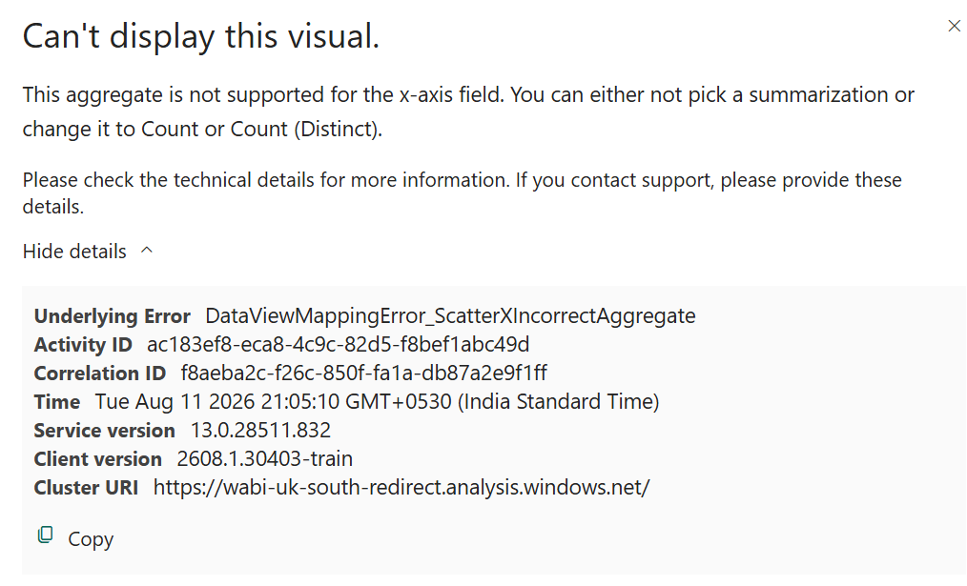
These two errors I don’t have idea
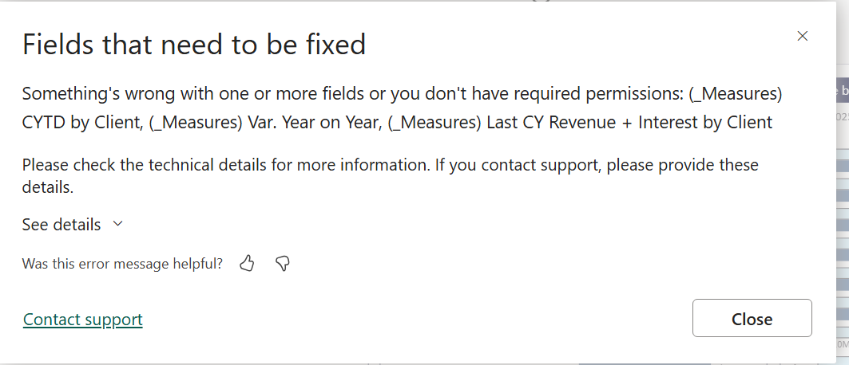
These three mesures or column I don’t know that is not inside the semantic model

